Algebra Qualifying Examination, Spring 2016

Instructions
Justify all the calculations and state the theorems you use in your answers. Each problem is worth 10 points.

Problems
- Let
$$A=\left(\begin{matrix}-3 & 3 & -2 \\ -7 & 6 & -3 \\ 1 & -1 & 2\end{matrix}\right)∈M_{3}(C)$$
  - Find the Jordan canonical form $J$ of $A$.
  - Find an invertible matrix $P$ such that $P^{-1}AP=J$. (You do not need to compute $P^{-1}$.)
- Let $K=Q[\sqrt{2}+\sqrt{5}]$.
  - Find $[K:Q]$.
  - Show that $K/Q$ is Galois, and find the Galois group $G$ of $K/Q$.
  - Exhibit explicitly the correspondence between subgroups of $G$ and intermediate fields between $Q$ and $K$.

  - State the three Sylow theorems.
  - Prove that any group of order 1225 is abelian.
  - Write down exactly one representative in each isomorphism class of (abelian) groups of order 1225.
- Let $R$ be a ring with the following commutative diagram of $R$-modules (each row represents a short exact sequence of $R$-modules).
- 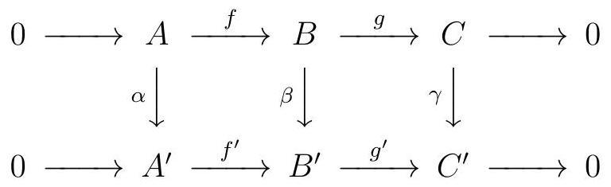
- Prove that if $α$ and $γ$ are isomorphisms then $β$ is an isomorphism.
- Let $G$ be a finite group acting on a set $X$. For $x∈X$, let $G_{x}$ be the stabilizer of $x$, and $G⋅x$ be the orbit of $x$.
  - Prove that there is a bijection between the left cosets $G/G_{x}$ and $G⋅x$.
  - Prove that the center of every finite $p$-group $G$ is non-trivial by considering the action of $G$ on $X=G$ by conjugation.
- Let $K$ be a Galois extension of a field $F$ with $[K:F]=2015$. Prove that $K$ is an extension by radicals of the field $F$.
- Let $D=Q[x]$ where $Q$ are the rational numbers and let $M$ be a $Q[x]$-module such that
$$M≅\frac{Q[x]}{(x-1)^{3}}⊕\frac{Q[x]}{(x^{2}+1)^{3}}⊕\frac{Q[x]}{(x-1)(x^{2}+1)^{5}}⊕\frac{Q[x]}{(x+2)(x^{2}+1)^{2}}.$$
- Determine the elementary divisors and invariant factors of $M$.
- Let $R$ be a simple rng (a nonzero ring which is not assumed to have a $1$, whose only two-sided ideals are $\{0\}$ and $R$) satisfying the following two conditions:
  - $R$ has no zero-divisors; and
  - if $0≠x∈R$ then $2x≠0$ (where $2x:=x+x$).
- Prove the following:
  - For each $x∈R$ there is one and only one element $y∈R$ such that $x=2y$.
  - Suppose $x,y∈R$ such that $x≠0$ and $2(xy)=x$. Then $yz=zy$ for all $z∈R$.
- [You can get partial credit for part (b) if you do it assuming $R$ has a $1$.]

